USER MANUAL FOR

Appointment Schedule for Sample Collection

APPLICATION

After Starting server in local instance copy the local-host address in case its default address is:

<https://arika85.herokuapp.com/>

Image-1:

This will be the welcome screen with users inputs given for reference

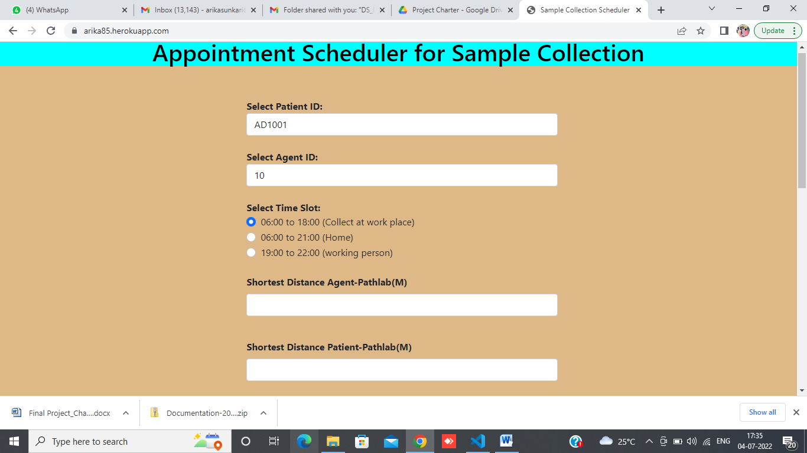

Image-2

Mandatory fields for user-end to enter/choose for prediction (Values entered for Reference)

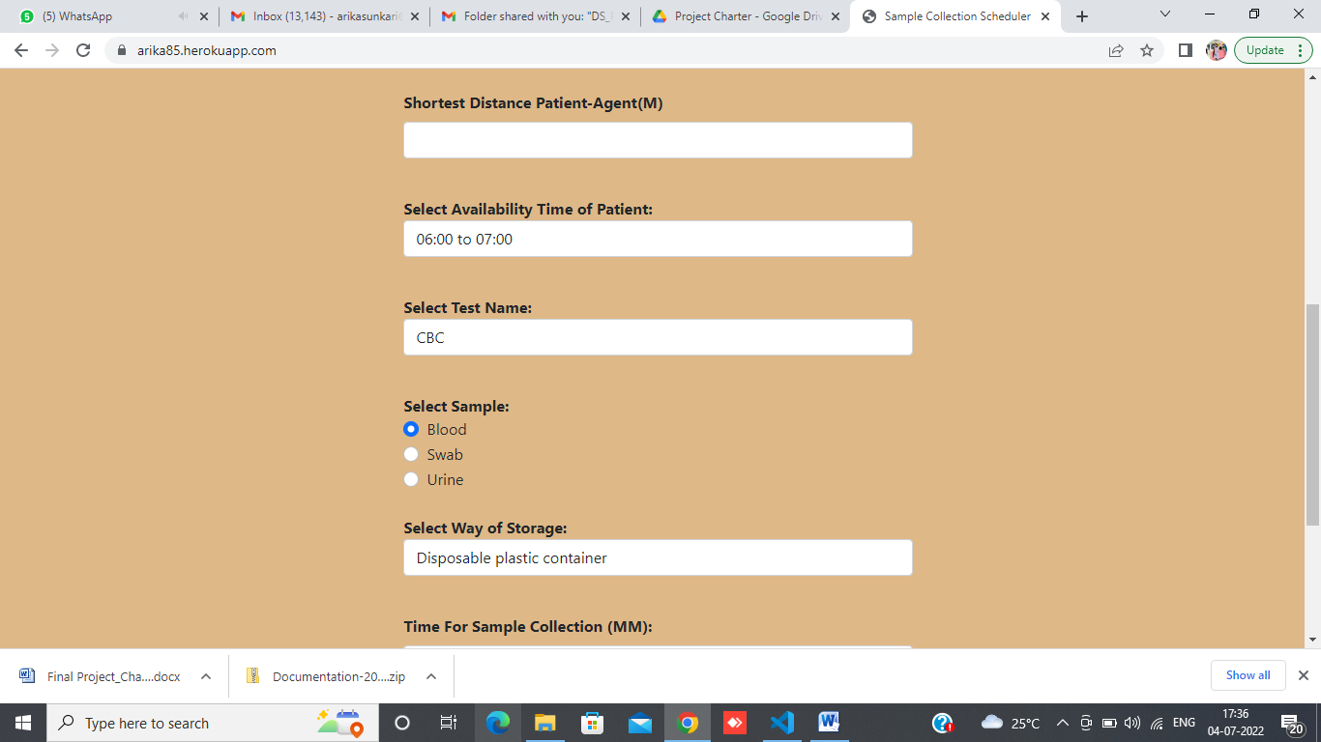

Image - 3

Result/output of Prediction

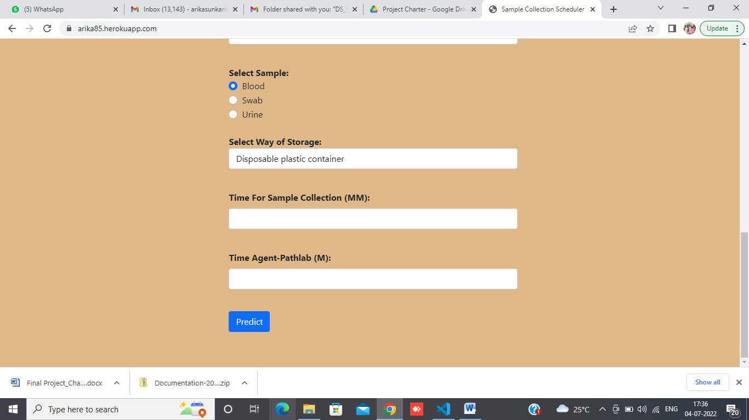

**THANK YOU**